Assignment 1 External Documentation

John Cetin

100955200

COMP3064

# Table of Content

Table of Contents

Table of Content 2

Detailed Game Description 3

Control Description 3

Interface Sketch 3

Screen Descriptions 3

Enemies 3

Scoring 3

Sound Index 3

Art/Multimedia Index 4

# Detailed Game Description

Firefight is a 2D space shooter where the player takes control of a space ship and has to avoid/destroy enemy ships coming its way. The player will be able to shoot and movie around in the game. They can collect gems which will increase the score that the player can get. The player will have health and when all health is depleted, it is game over.

# Control Description

The player can move the space ship with the arrow keys or the WASD keys. The player can shoot by pressing the “m” key.

# Interface Sketch

# Screen Descriptions

Start State

Gameplay State

Game-End State

# Enemies

The enemies in the game are the black space ships that head towards your way. If you get hit by one, the you will take damage.

# Scoring

The player can get points by collecting the green gems that appear random in the game. Another way to score points is if the player shoots down an enemy. Both will provide 10 points.

# Sound Index

# Art/Multimedia Index

Background

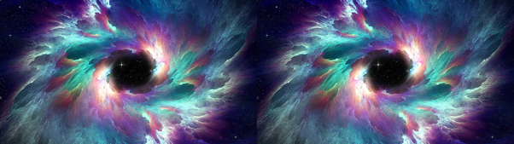

Player Ship

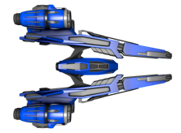

Enemy Ship

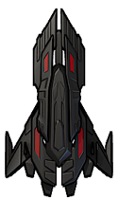

Gem

